EXPT NO: 8 | IMPLEMENTATION OF A SIMPLE AUTOENCODER FOR DIMENSIONALITY REDUCTION AND FEATURE LEARNING
DATE: 31-10-23

PRE-LAB QUESTIONS

1. Discuss the roles of the Encoder and Decoder in an Autoencoder.

The Encoder converts the input data into a compact representation by reducing its dimensions. It extracts important features and patterns from the original input data. The Decoder takes this compressed representation and attempts to reconstruct the original input. It learns to recover the important information from the encoded features. Together, the Encoder and Decoder help the Autoencoder learn meaningful representations of data.

2. Explain how an Autoencoder performs dimensionality reduction.

An Autoencoder performs dimensionality reduction by compressing the input data into a smaller representation called the latent space. The Encoder reduces the number of features while preserving important information. This compressed representation contains the essential characteristics of the original data. The Decoder uses these features to reconstruct the original input. Thus, the Autoencoder learns a lower-dimensional representation without requiring manually selected features.

3. Why is a bottleneck layer important in an Autoencoder architecture?

The bottleneck layer is the central part of an Autoencoder that stores the compressed representation of the input data. It contains fewer neurons than the input layer, forcing the network to learn important features. It prevents the model from simply copying the input directly to the output. The bottleneck helps remove unnecessary information and reduces data dimensionality. It also enables the extraction of meaningful features for further machine-learning tasks.

AIM
To implement and train a simple Autoencoder for dimensionality reduction and feature learning by compressing input data into a lower-dimensional representation and reconstructing the original data from the learned features.

SOFTWARE REQUIREMENTS
- Python
- TensorFlow / Keras / PyTorch
- Google Colab
- GitHub
- NumPy
- Matplotlib
- Pandas
- Scikit-learn

OBJECTIVES
Students will be able to:
- Understand the architecture and working of an Autoencoder.
- Identify the functions of the Encoder, bottleneck, and Decoder.
- Prepare and normalize input data for Autoencoder training.
- Build and train an Autoencoder using a suitable dataset.
- Perform dimensionality reduction through latent-space representations.
- Evaluate reconstruction performance using suitable loss metrics.
- Visualize reconstructed data and analyze the learned features.
- Document the experiment and manage the notebook using GitHub.

PROCEDURE
PART A: DATASET PREPARATION
Perform the following tasks:
- Load a suitable dataset, such as the MNIST handwritten digits dataset.
- Explore the dataset and examine sample input images.
- Identify the dimensions and data types of the input samples.
- Normalize the pixel values to a suitable range, such as 0 to 1.
- Reshape the input images into one-dimensional vectors if using a Dense Autoencoder.
- Split the dataset into training and testing datasets.
- Use the input data as both the input and target output for reconstruction.
- Display a sample of the original images.

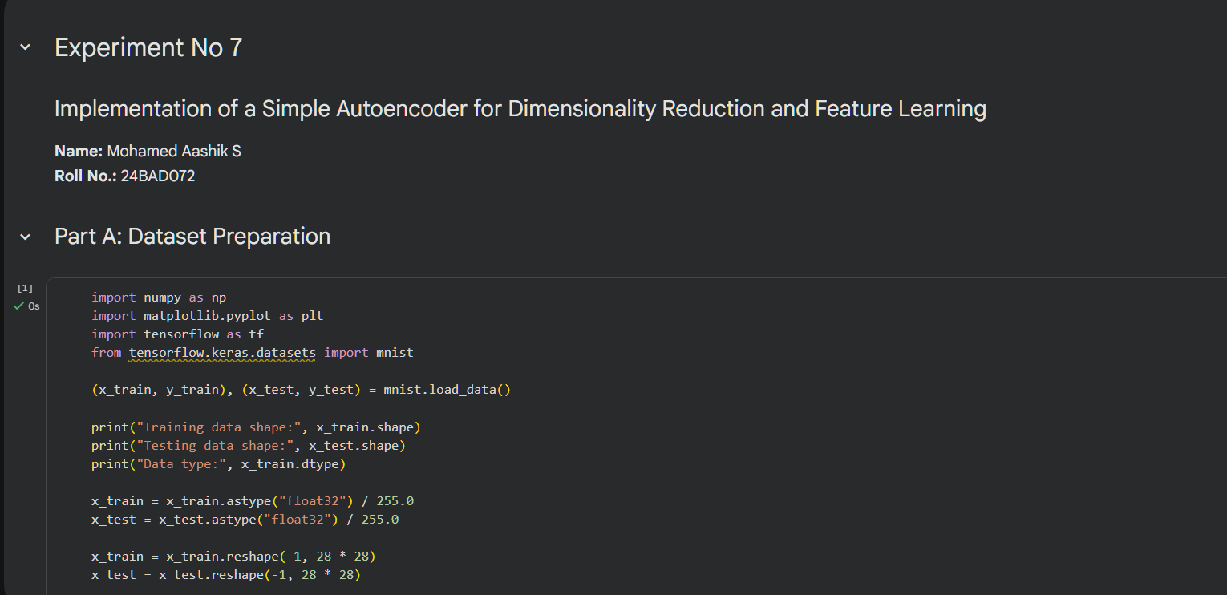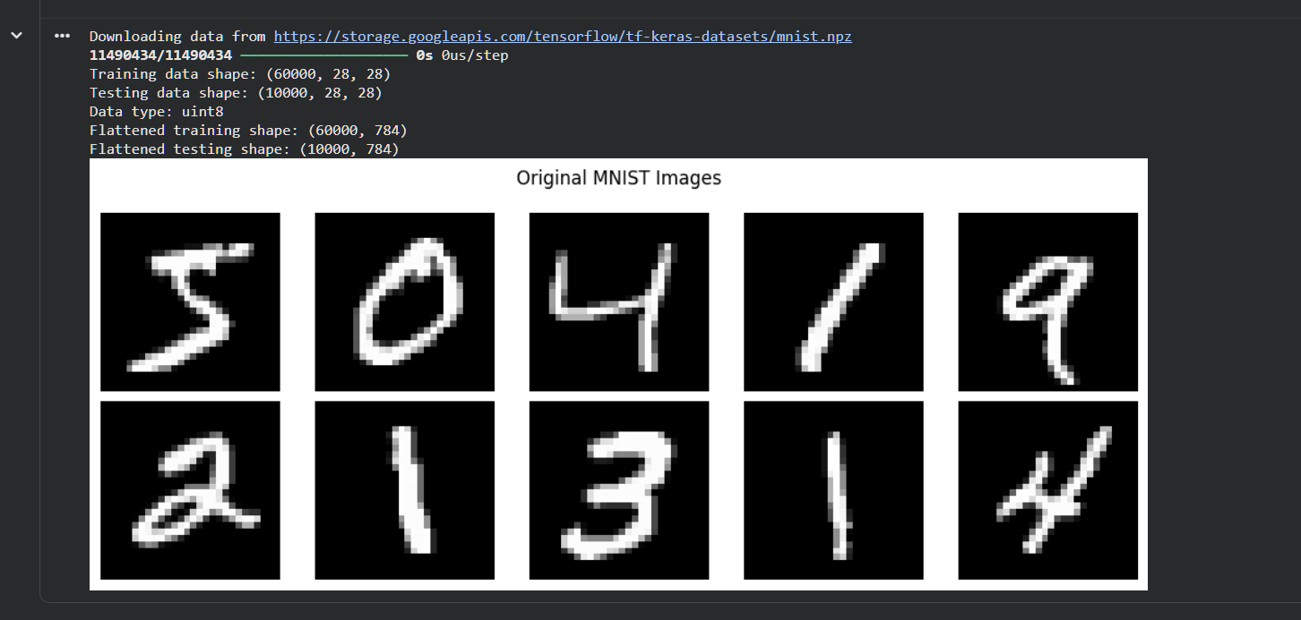
PART B: IMPLEMENTING THE AUTOENCODER MODEL
Perform the following tasks:
- Define the input layer based on the dimensions of the dataset.
- Create an Encoder using one or more Dense layers.
- Introduce a bottleneck layer with fewer neurons than the input layer to learn a compact representation.
- Create a Decoder to reconstruct the input from the bottleneck representation.
- Use a suitable activation function, such as ReLU for hidden layers and Sigmoid for normalized image reconstruction.
- Combine the Encoder and Decoder to construct the complete Autoencoder.
- Compile the model using an appropriate optimizer, such as Adam, and a reconstruction loss function, such as Mean Squared Error (MSE).
- Display the model architecture and model summary.

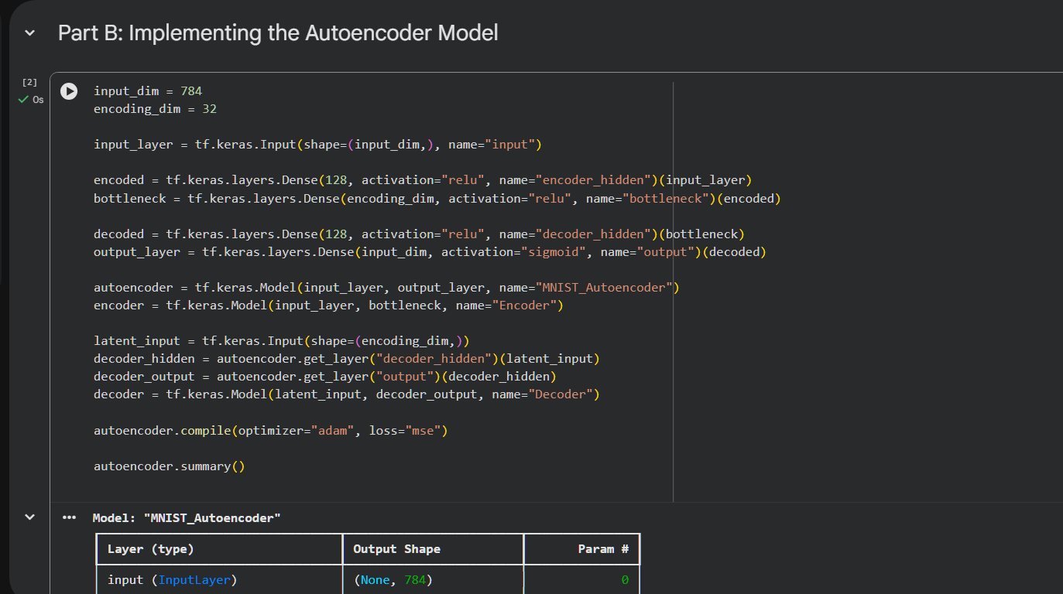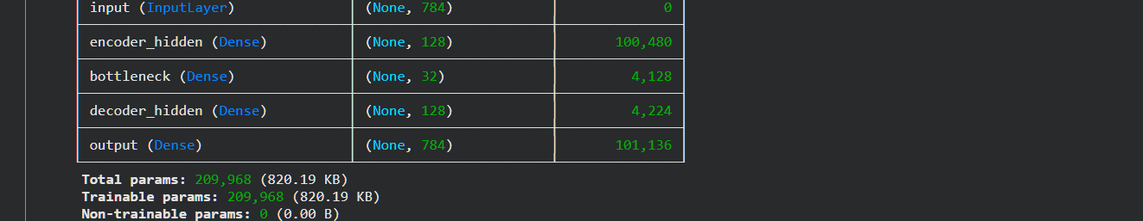

PART C: MODEL TRAINING AND PERFORMANCE EVALUATION
Perform the following tasks:
- Train the Autoencoder using the prepared training dataset.
- Use the original input samples as target outputs.
- Validate the model using validation data or the testing dataset, as appropriate.
- Record:
  - Training loss
  - Validation loss
- Evaluate the trained model using the test dataset.
- Calculate the reconstruction Mean Squared Error (MSE).
- Plot the training and validation loss against the number of epochs.
- Compare the original input images with their reconstructed outputs.

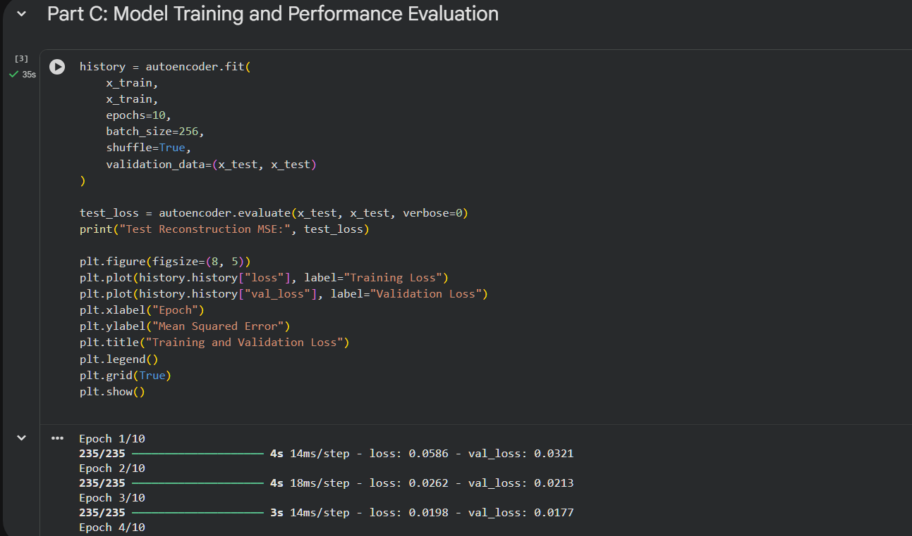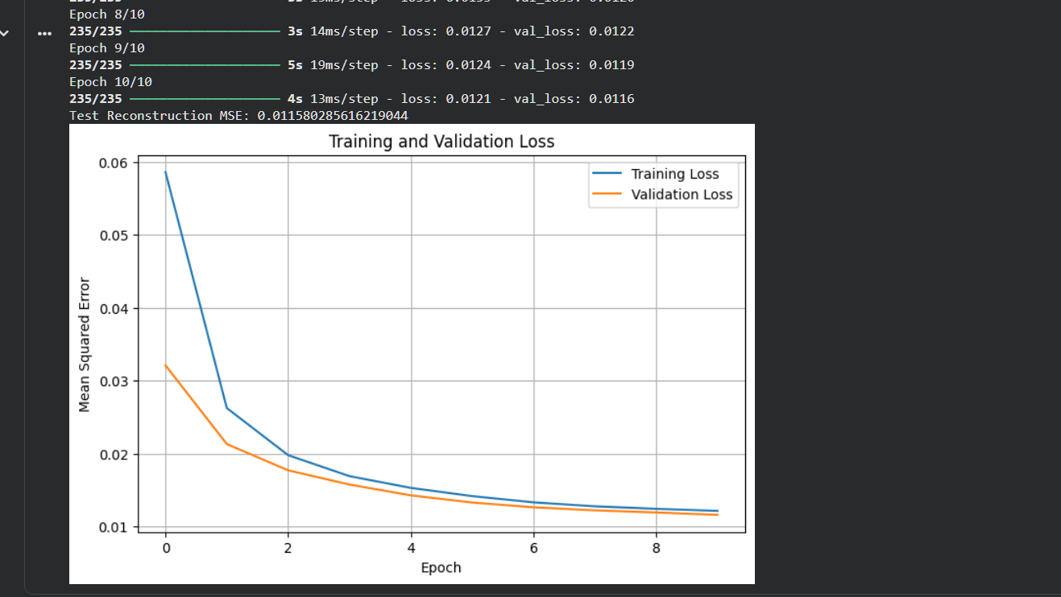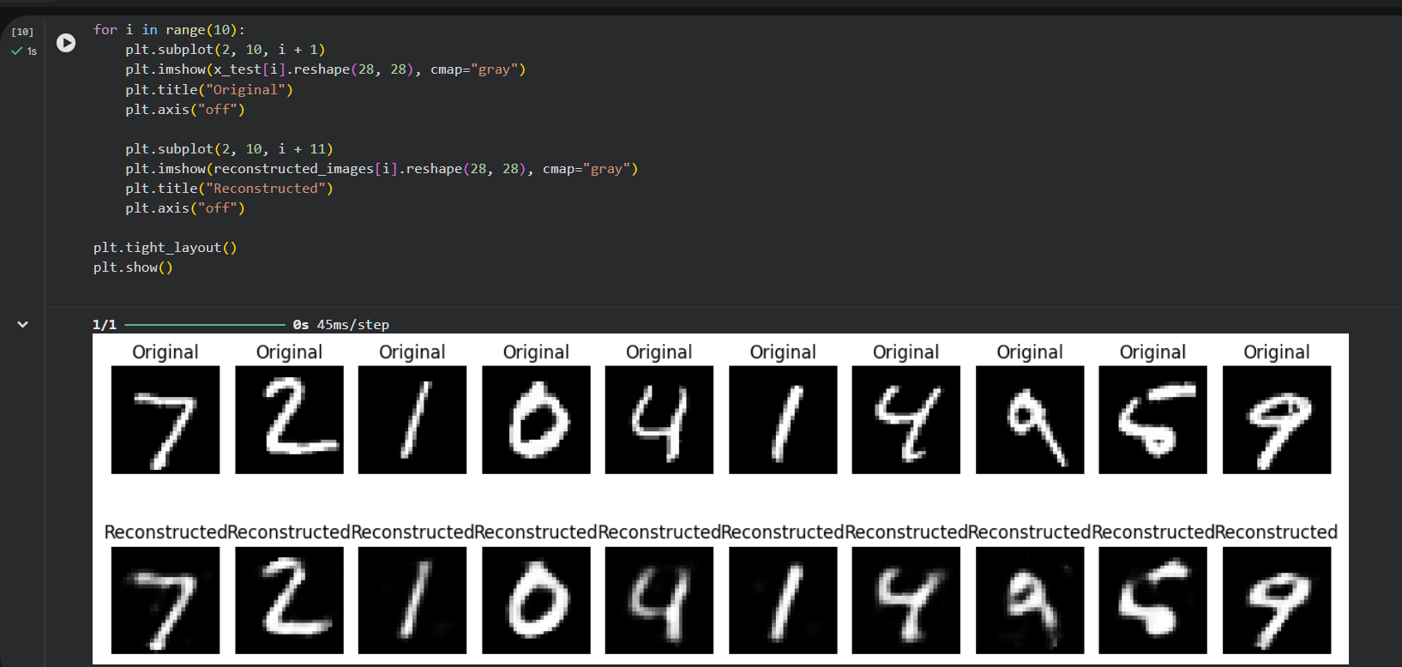

PART D: DIMENSIONALITY REDUCTION, FEATURE VISUALIZATION AND EXPERIMENT MANAGEMENT

Perform the following tasks:
- Provide new movie-review sentences as input to the trained LSTM model.
- Extract latent-space representations of test samples using the trained Encoder.
- Compare the dimensions of the original input data and compressed representations.
- Visualize the latent representations using a suitable plot.
- Reconstruct selected test samples using the Decoder and compare them with the original images.
- Record observations on dimensionality reduction and reconstruction quality.
- Document the observations and upload the notebook to GitHub.

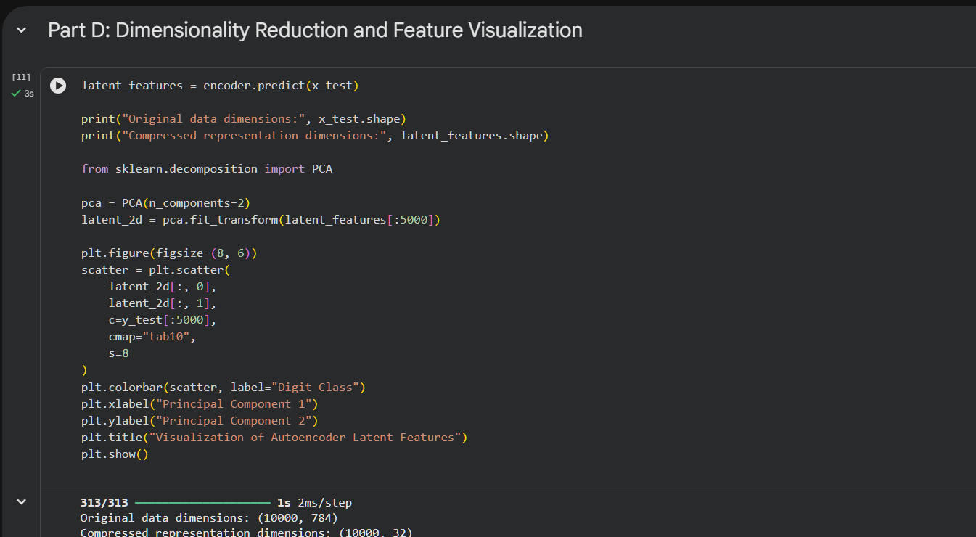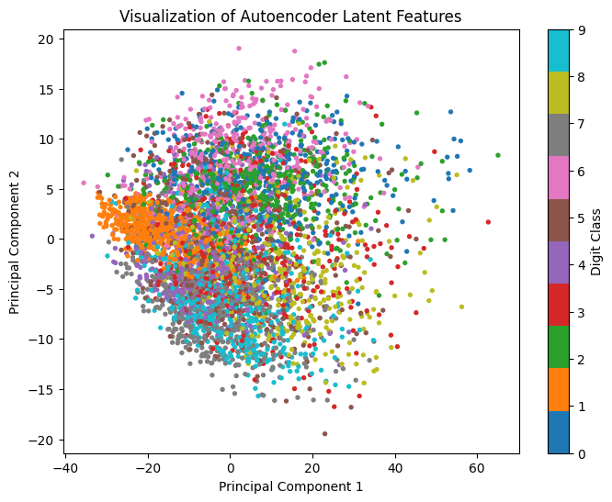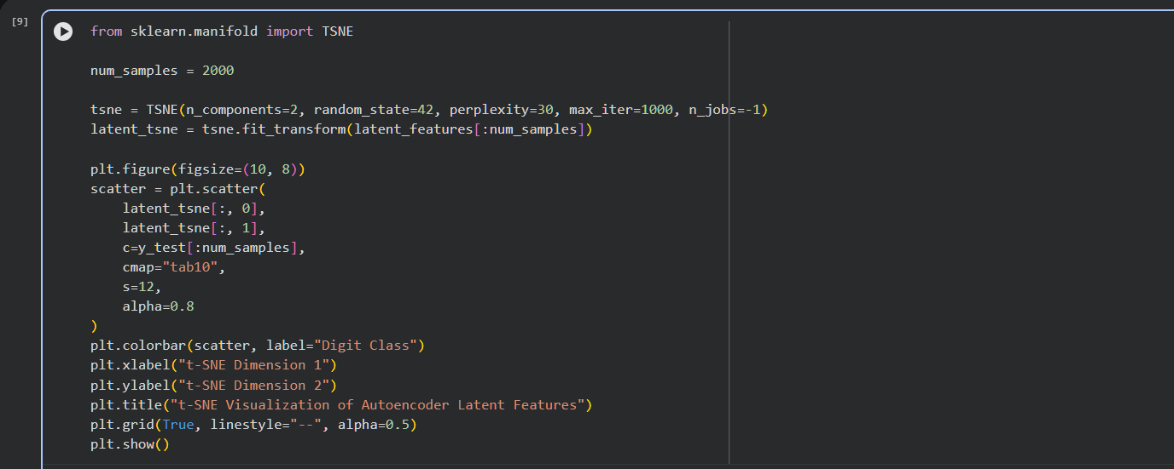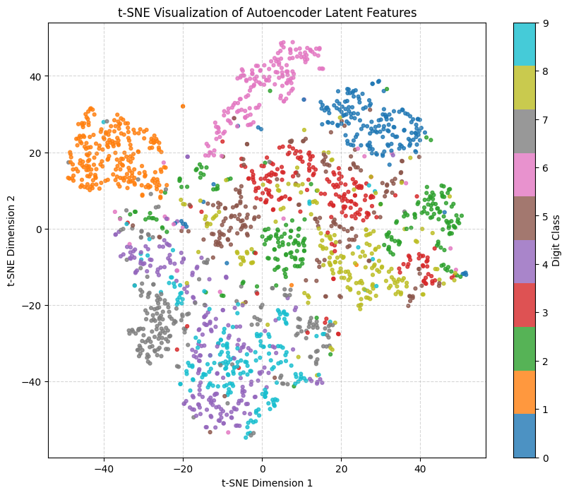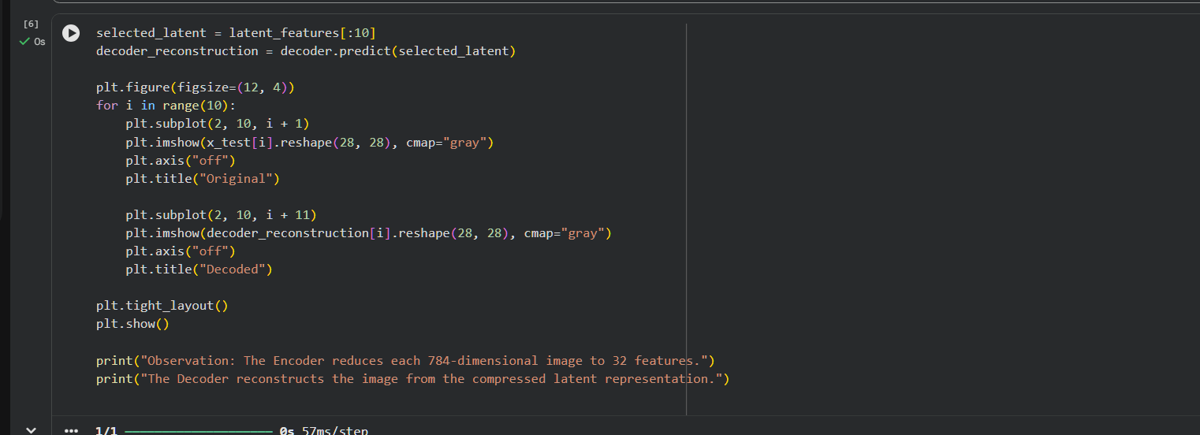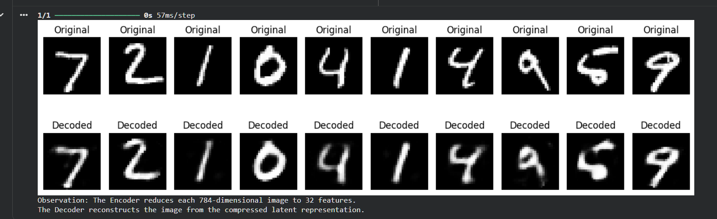

POST-LAB QUESTIONS

1. Explain the significance of reconstruction loss in training an Autoencoder.

Reconstruction loss measures the difference between the original input data and the reconstructed output produced by the Autoencoder. It helps determine how accurately the model can reproduce the input data. During training, the model minimizes this loss by updating its weights using backpropagation. Mean Squared Error (MSE) is commonly used to calculate reconstruction loss for image data. A lower reconstruction loss generally indicates better reconstruction performance.

2. State one advantage of Autoencoders over traditional dimensionality-reduction techniques.

One major advantage of Autoencoders is their ability to learn complex nonlinear relationships in data. Traditional techniques such as Principal Component Analysis mainly capture linear relationships between features. Autoencoders use neural networks to learn more flexible and meaningful representations. They can handle complex datasets such as images and other high-dimensional data. Therefore, Autoencoders are useful when the underlying data patterns are nonlinear.

3. Discuss two practical applications of Autoencoders apart from dimensionality reduction.

Autoencoders are widely used in anomaly detection to identify unusual patterns in data. They learn to reconstruct normal data accurately, while abnormal data generally produces higher reconstruction errors. Another application is image denoising, where Autoencoders remove unwanted noise from corrupted images. They learn the important features of clean images and reconstruct clearer outputs. These applications make Autoencoders useful in healthcare, cybersecurity, image processing, and industrial monitoring.

ASSESSMENT
Description | Max Marks | Marks Awarded
Pre Lab Exercise | 5
In Lab Exercise | 10
Post Lab Exercise | 5
Viva | 10
Total | 30
Faculty Signature

